

Cognos Reverse Smart Connector

Installation Guide

Version 1.0

# 

Table of Contents

1. Introduction 3

1.1 Overview 3

1.2 Scope 3

1.3 Supported Operating Systems 3

2. Pre-requisites 3

2.1 Server Level Access 3

2.2 Erwin DIS User Access 3

3. Installing the Connector 4

3.1 Steps to be performed on the server 4

3.2 Steps to be performed on Erwin DIS Application 7

1. Introduction
   1. Overview

The Cognos Reverse Smart Connector is used to reverse engineer Cognos reports and create mappings in Erwin Data Intelligence Suite (DIS). The Connector creates the mappings under individual Subject areas named after the package used in the Cognos report.

This document aims to provide the steps to be followed to deploy the Cognos connector to an existing DIS instance.

The steps to be followed are the same for both Windows and Linux based operating systems. The operation consists of two parts.

1. Placing the required supporting files in the required locations on the server where DIS is installed
2. Importing the connector into the Automation Framework module using the Import Connector functionality of DIS
   1. Scope

* Installation of required supporting files in the DIS Server.
* Importing the connector into Erwin DIS
  1. Supported Operating Systems
* Windows/Linux

# 

1. Pre-requisites
   1. Server Level Access

* The installation of the connector files is to be done on the server where DIS has been installed
* The user performing the connector install should have access to modify files in the directory where tomcat is installed. The user may require Administrator/root access to modify files depending on the tomcat installation location
* The Connector files shared as part of the deployment package should be placed on the server where DIS is configured for easy access
* Note: The Tomcat service will need to be shutdown for the duration of the connector install. The applications running on the Tomcat server will be down temporarily till the service is started again
  1. Erwin DIS User Access
* The user performing the import of the connector should have access to the Automation Framework Module in DIS

1. Installing the Connector
   1. Steps to be performed on the server

* Check if the user logged into the system has access to modify files in the tomcat installation path and has permissions to stop the Tomcat service
* Make sure the deployment package shared by Erwin contains a folder with the supporting jar files
* Stop the Tomcat service if it is already running, follow the steps below to stop tomcat based on the operating system
  + Windows System
    - Click on the start button at the bottom left corner of the screen
    - In the search bar, type in “Services” and locate the Services Application in the results

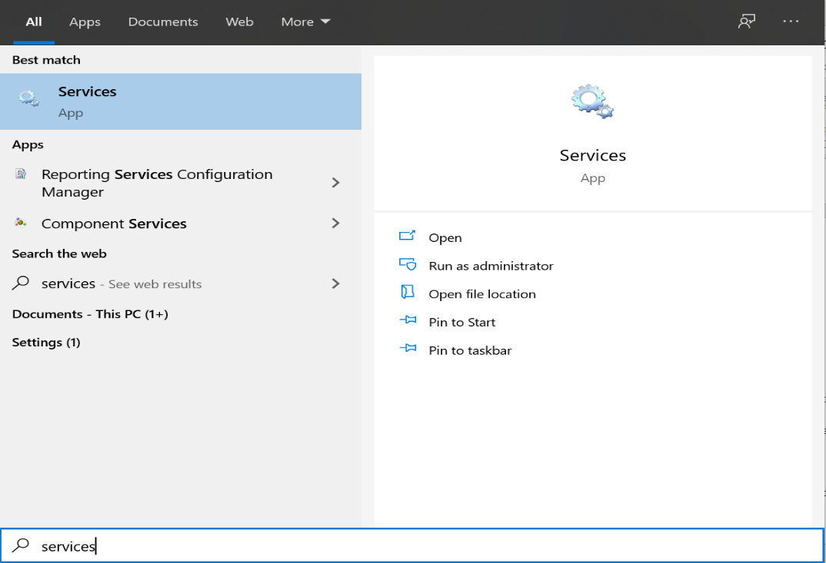

* + - Open the Services Application and find the “Apache Tomcat” service in the list of services

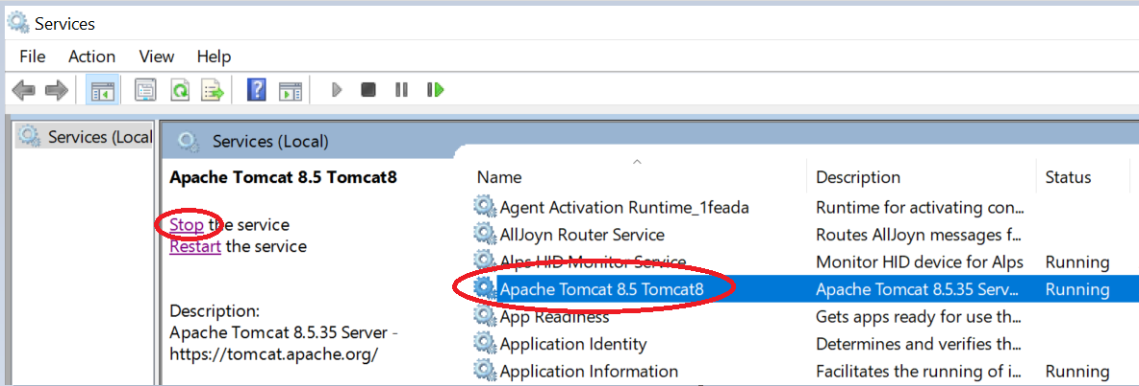

* + - Click on the service and then click on the Stop the service option to stop the Tomcat Service.
  + Linux System
    - Open a terminal window and navigate to the tomcat installation directory
    - Open the “bin” directory in the tomcat folder and run the shutdown.sh command to stop the Tomcat Service

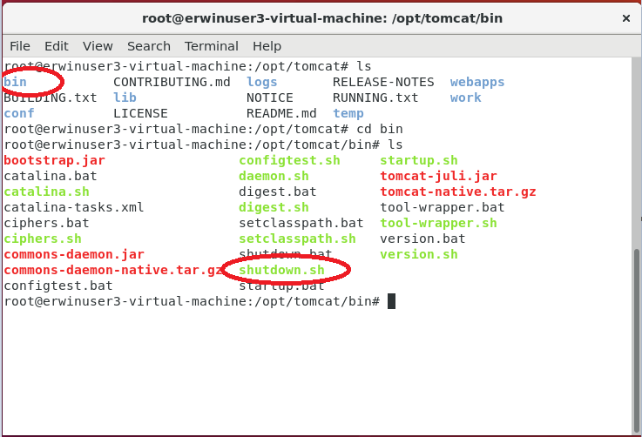

* Once the service is shutdown, open and clear the logs folder in the tomcat directory by deleting the log files
* Identify the application path for the DIS instance in tomcat, the application folder will be present in the webapps folder of tomcat.
* The generic path to the lib directory on the DIS instance is as follows:
  + *\*tomcat installation directory\**/webapps/*\*erwinDIS directory\**/WEB-INF/lib
* In the lib directory of the DIS instance, check if there is a “gsp.jar” file available and remove the file from the directory.
* Copy all the supporting jar files from the deployment package shared by Erwin and place the files in the lib directory of the DIS instance
* After the files are copied into the lib directory, restart the Tomcat server.
  + Windows
    - On the services app, click on the Apache Tomcat service and click on the “Start the service” link

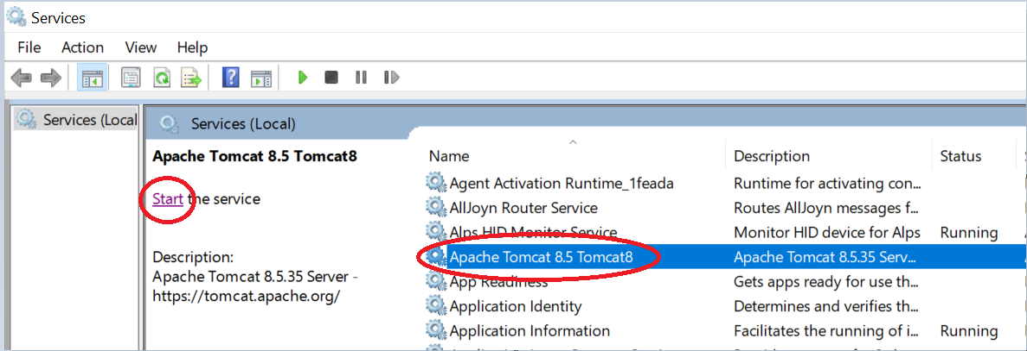

* + Linux
    - Navigate to the bin directory of the tomcat installation directory and run the startup.sh command to start the tomcat server

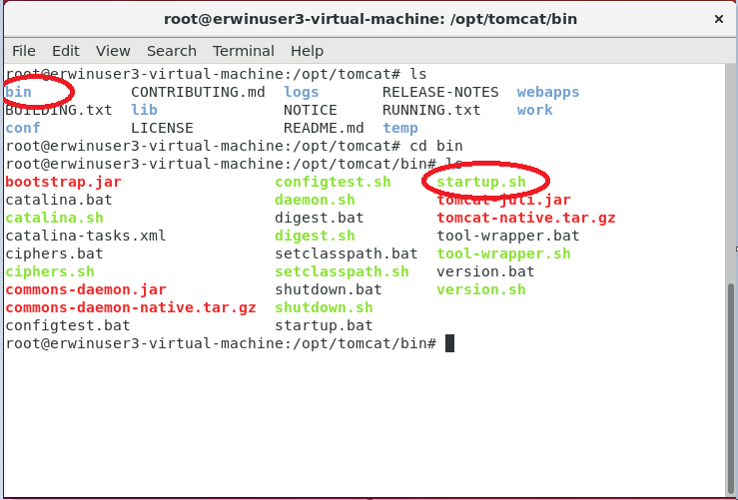

* 1. Steps to be performed on Erwin DIS Application
* Check if the Deployment package shared by Erwin has a folder containing .acp files. We will need those files to be imported into the DIS application to run the Cognos Connector
* Login to Erwin DIS application with a user who has access to the “Automation Framework” module.
* Click on the tile icon on the top left corner of the screen and navigate to the Automation Framework Module

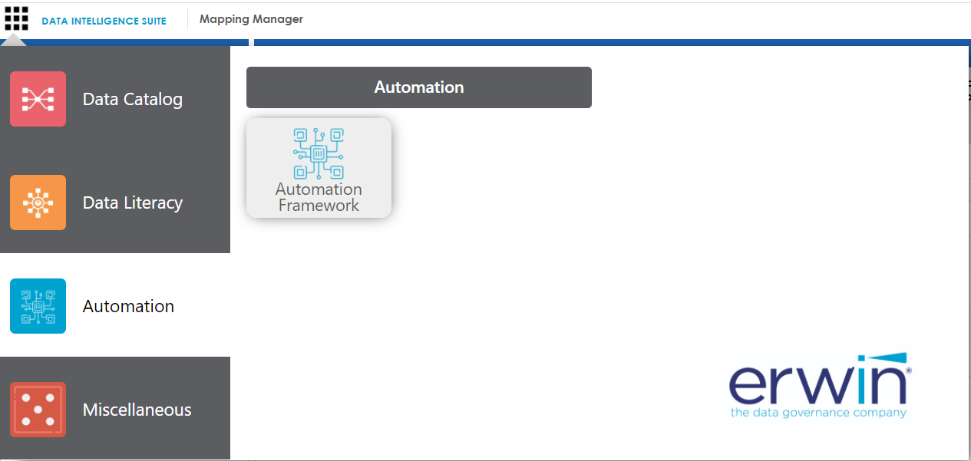

* Here under the CATs tab, we need to click on the Import Template option at the far right of the page and select the .acp file from the deployment package.

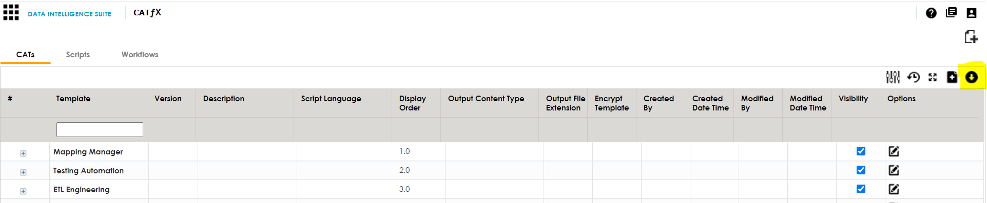

* In the pop-up window, click on the “Override with existing” option. This will replace any older version of the connector if already present on the DIS.

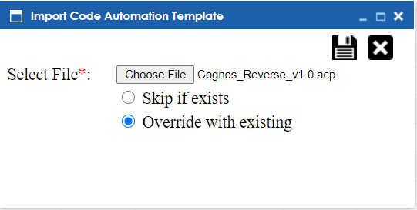

* Click on the “Save” icon on the top right of the pop-up window to finish the import process.
* Refresh the page and Check for the Cognos connector template under BI Reverse Group

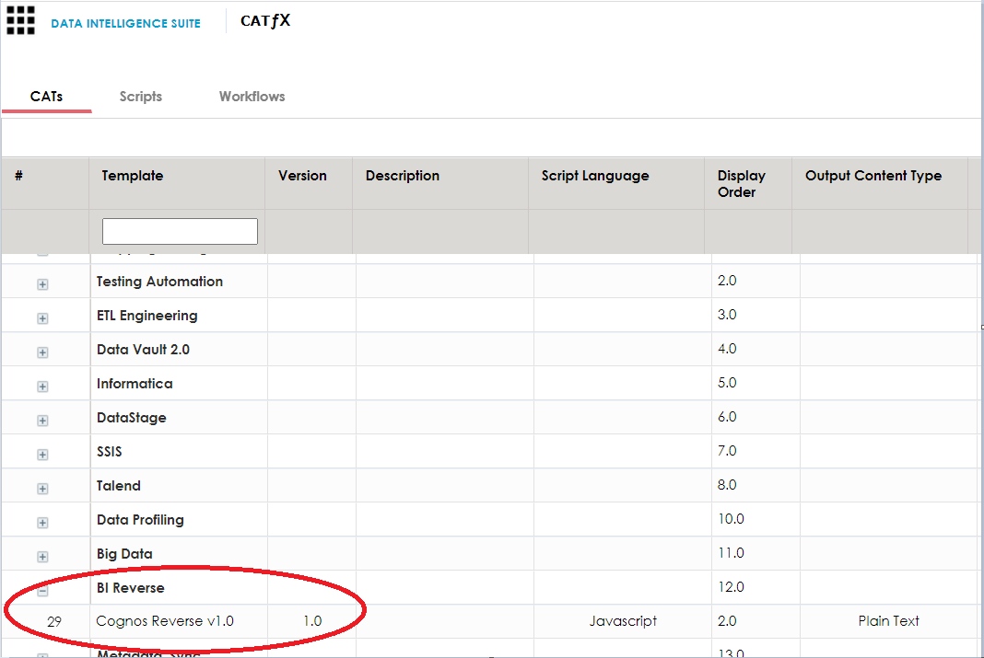

The connector has now been successfully installed onto the DIS instance, refer to the User Guide for the connector to understand the configuration options and steps to run the connector.

For any questions regarding the installation process please reach out to Erwin